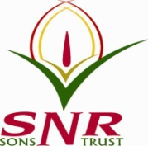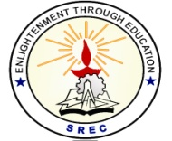**SRI RAMAKRISHNA ENGINEERING COLLEGE**

[Educational Service: SNR Sons Charitable Trust]

[Autonomous Institution, Accredited by NAAC with ‘A’ Grade]

[Approved by AICTE and Permanently Affiliated to Anna University, Chennai]

[ISO 9001:2015 Certified and all eligible programmes Accredited by NBA]

**VATTAMALAIPALAYAM, N.G.G.O. COLONY POST, COIMBATORE – 641 022**

**SREC – IPR CELL**

**Date: 12.07.2021**

**Report on IPR Workshop for Faculty:**

A live demo on Clarivate's flagship patent solution - Derwent Innovation was held on Monday, 12th July 2021 for the faculty of Sri Ramakrishna Engineering College. “Creating better IPR Strategy with Smart Search-Live Tool Demo” was presented by Mr Abhijeet Patil, Solutions Consultant, Clarivate. Mr. S. Vasant, Regional Account Manager, Clarivate also present during the workshop.

Dr. S. Deivanayaki, Assistant Professor (Sl.Grade)/Physics welcomes the gathering, The introduction to the resource person was given by Mr. S. Ranjithkumar, Assistant Professor/CSE. There are 68 faculty attended the online workshop and got benefitted out of it. Dr. R. Kingsy Grace,

Associate Professor/CSE delivers the vote of thanks.

The live demo was focused to,

* Strengthen the innovation strategy through Derwent Innovation which provides a 360° view of innovation landscape, including scientific literature and foreign material
* Support technology commercialisation through understanding patent strengths and potential partners
* Support selection of “right research” through embedding patent intelligence in the literature review process

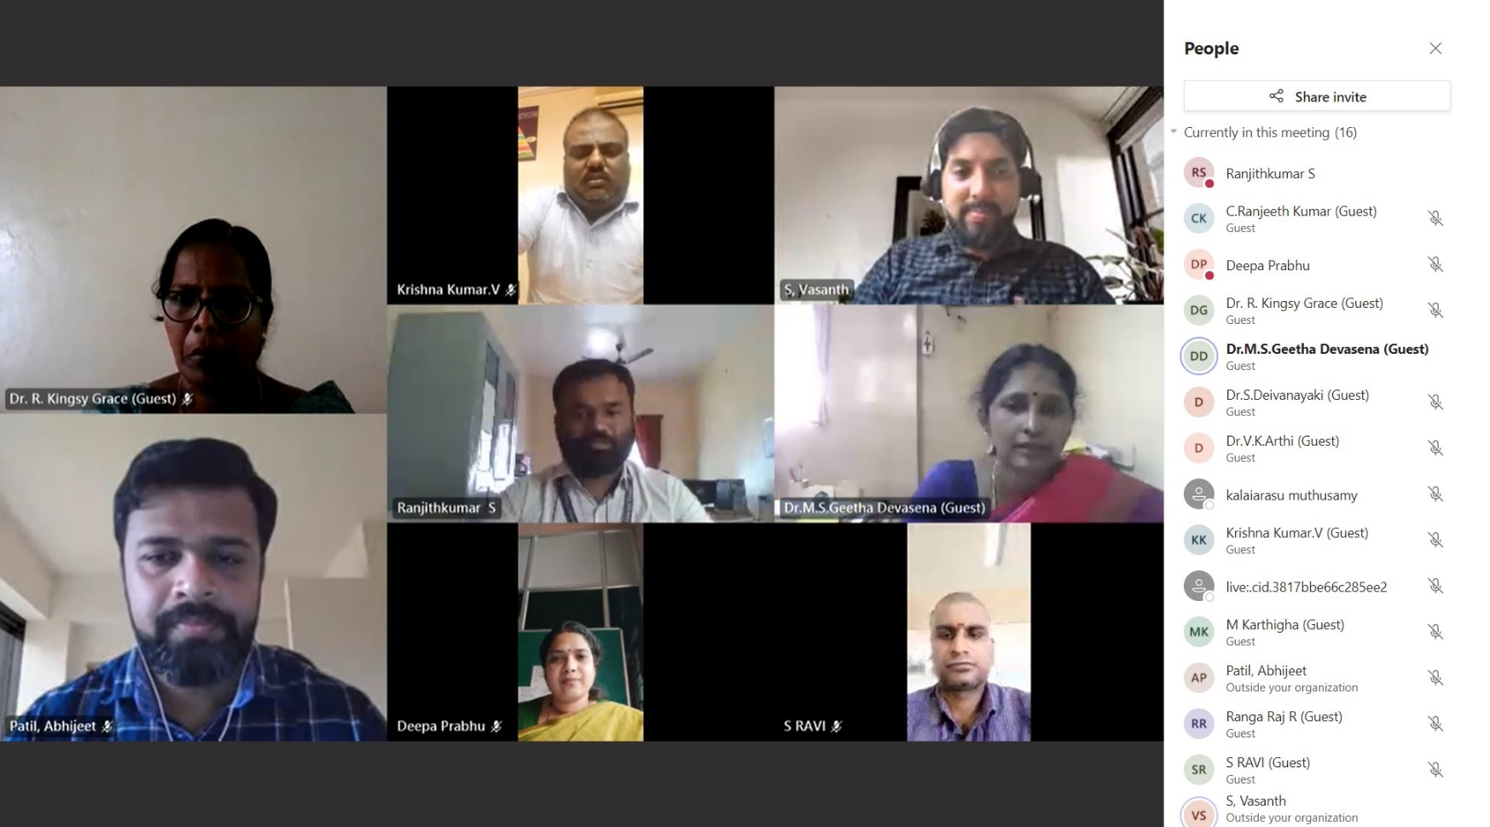

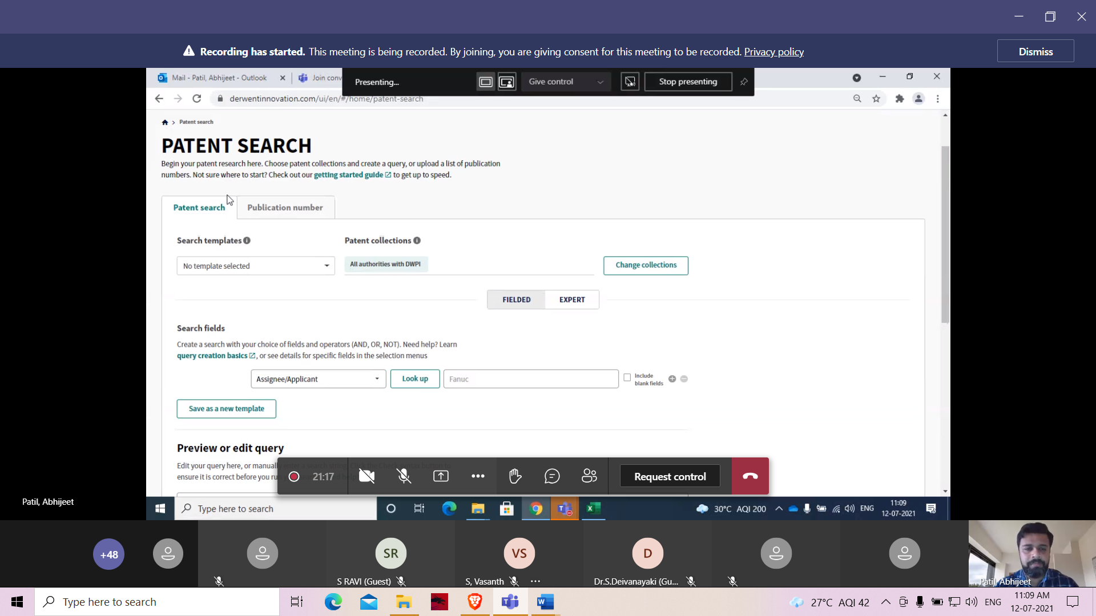

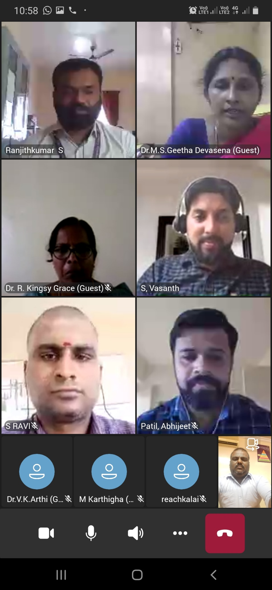

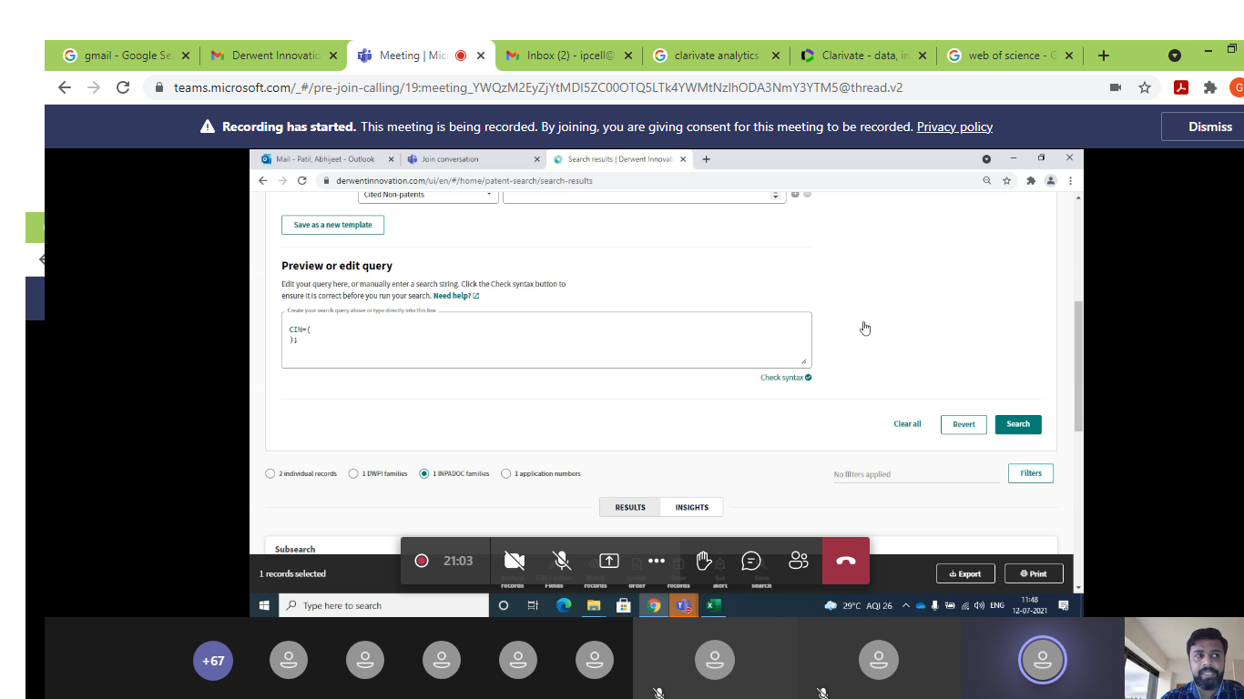

**HEAD – IPR CELL**

**Dr. M. S. Geetha Devasena, P/CSE**